Local Axes Guidelines

The BATProbe database set up after a GCS survey contains two types of axes:
- Global axes
- Local Axes

The Global axes are a mandatory set of axes and are set up identically across countries, based on instructions available in the Global BATProbe Template which has previously been agreed with Globe House.

The local axes on the other hand are set up to meet specific requirements of individual countries. As such, their definitions are not part of the Global template and need to be specified at the time of BATProbe setup. Infotools have no fixed template for the local axes as they differ over different markets and databases - therefore clear instructions are needed on exactly what is required. This is the responsibility of the local market to ensure that Infotools are provided with clear specifications for any local axes.

The different types of local content that can exist in BATProbe databases currently are:
- Local Rider questions/section
- Local demographics
- Local versions of template axes
- Additional local brand sections
- Local DCS classifications
- Local brand levels
This document outlines the process of including local axes in the BATProbe database, the implications and other considerations for including these axes.

1.1 The process for including local axes in BATProbe databases

Since there is no standard template document on local axes Infotools and the Global GCS Hub require:

- Local requirements are to be specified in the DCS in terms of:
  - Which local axes are to be setup
  - Clear instruction on how to set up each local axis required
Requirement for each type of local axis is specified in the Appendix.
- All local requirements instructions are required prior to the start of database set-up
- Most local requirements outside of the “Rider” section will be identified by having “-Local” at the end of the axis
- If extra requests or information supplied after database set-up has commenced then an additional cost may be incurred.
1.2 The implications (e.g. timing impacts, costs)

- Local axes typically have a significant impact on the time taken for database signoff. This impacts the time and costs of the Global GCS Hub and Infotools.
- 5-10 local axes could be considered reasonable and can often be managed within the same time and costs as the Global axes, provided definitions required for set-up are clearly specified upfront. However, several markets are having more than this, therefore this impacts time and costs of the BATProbe databases.
- Any market who has more than 10 local axes should review whether these are required. Some markets have more than 50 local axes, and a few markets more than 100. Please be aware that such a high number of local axes are costly, and time consuming to maintain. Please review your market’s local axes and shortlist where possible.
- The time and cost required for setup and audit of local axes will depend on the number of axes in the specific market and the scope of work for these axes. A rate and time card will be provided for this on an individual basis.

Appendix – Types of Local axes

- Local rider questions/section instructions (e.g. Korea GCS W2 2011)
- Will be located under the section header “RIDER” towards the end of the BATProbe database.
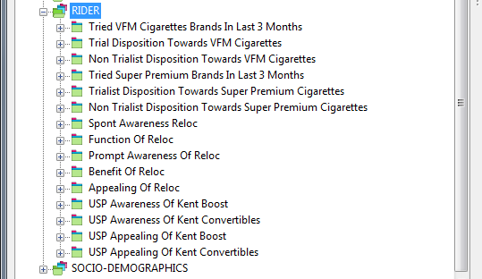
- Will be set up as per the questionnaire and supplied data (Infotools may alter the labels slightly to follow ITL Database Design practices. i.e. abbreviating & shortening labels or to harmonise with previous waves).
- ”Don’t Know” responses will be grouped into an “Unclassified” element unless requested otherwise
- Any extra/special requests must be clearly communicated in the “Local Definitions” tab of the DCS at the time of initial DCS/data supply to Infotools Supply any briefing notes in the DCS here for your requirements for set-up.
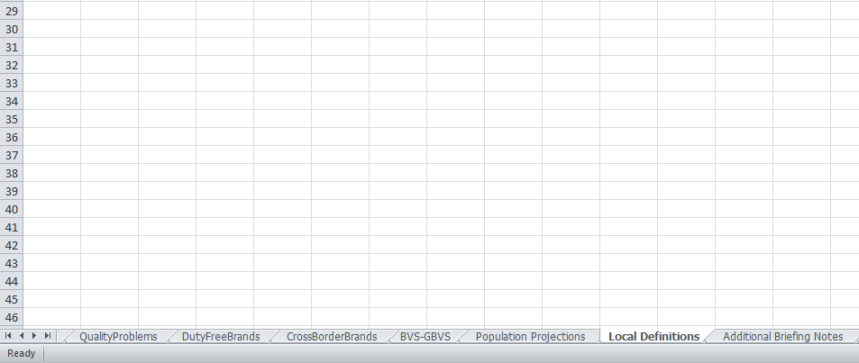

- Local demographics
- Will be located under the section header “SOCIO-DEMOGRAPHICS” at the end of the BATProbe database

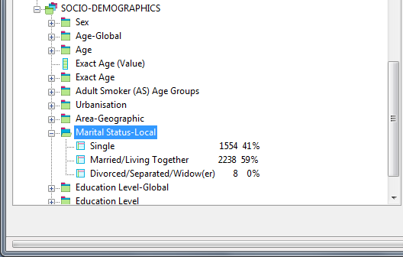
- Will be set up as per the questionnaire and supplied data (Infotools may alter the labels slightly to follow ITL Database Design practices. i.e. abbreviating & shortening labels or to harmonise with previous waves.
- ”Don’t Know” responses will be grouped into an “Unclassified” element unless requested otherwise
- Any extra requests must be clearly communicated in the “Local Definitions” tab of the DCS at the time of initial DCS/data supply to Infotools

- Local versions of template axes
- Each of these axes will be located directly below the location of the equivalent template axis in the BATProbe database
- Will have “-Local” at the end of the axis name
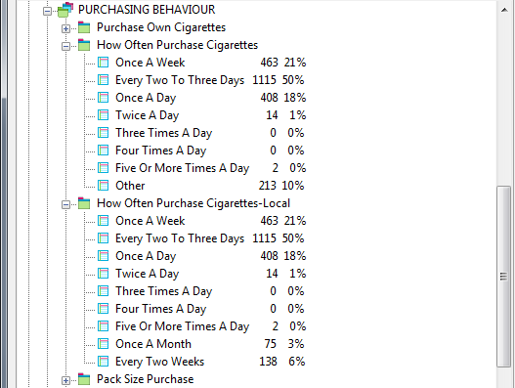
- Will be set up as per the questionnaire and supplied data (Infotools may alter the labels slightly to align with labels previously used for the same or other markets)
- If being set-up for the first time then local labels will be aligned to the questionnaire as closely as possible. If the local elements are to be grouped or netted to follow a specific local label mapping different to the above then the mapping must be supplied as a separate tab in the DCS at the time of initial data/DCS supply to Infotools

- Additional local brand sections
- If following the main brand list, a full brand section may be setup for all brand levels and classification groups.
- If a unique brand list is require then this must be provided as a separate sheet in the DCS with all required classification information populated.
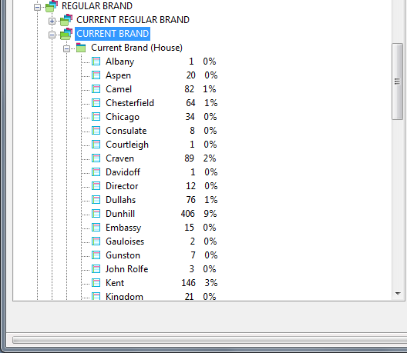
- Local DCS classifications
- Additional columns need to be populated at the end of the “Classifications” sheet in the DCS
- All rows for all brands need to contain a classification
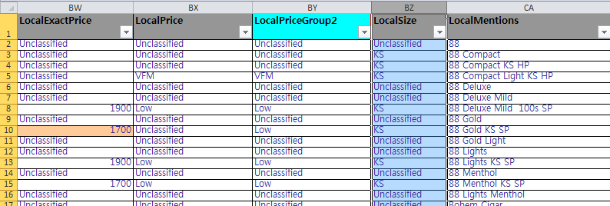

- Needs to be supplied at the time of initial data/DCS supply to Infotools
- Will have “-Local” at the end of the axis name
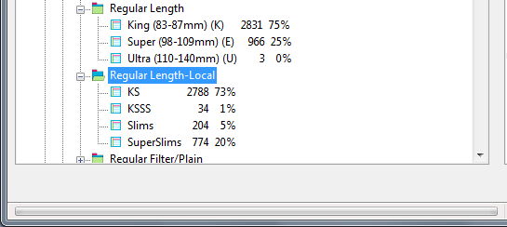

- Local brand levels
- Additional columns need to be populated at the end of the “Classifications” sheet in the DCS
- All rows for all brands need to contain a classification
- Needs to be supplied at the time of initial data/DCS supply to Infotools
